

**Department of CSE**

**CSE209 Lab**

**Course Name: Electrical Circuits**

**Course Code: CSE209**

**Section No: 2**

**Experiment No: 02**

**Name of the Experiment:** Series-Parallel DC Circuit and Verification of Kirchhoff’s Laws.

**Date of submission: 10/8/2021**

Student’s Name: Md Abdul Ahad Rifat

Student’s ID: 2020-1-60-215

**Submitted to**

Rashedul Amin Tuhin

Senior Lecturer

Department of Computer Science and Engineering

East West University

**Objectives:**

1. To learn analysis of dc series-parallel circuit.

2. To verify Kirchhoff’s Voltage Law (KVL).

3. To verify Kirchhoff’s Current Law (KCL).

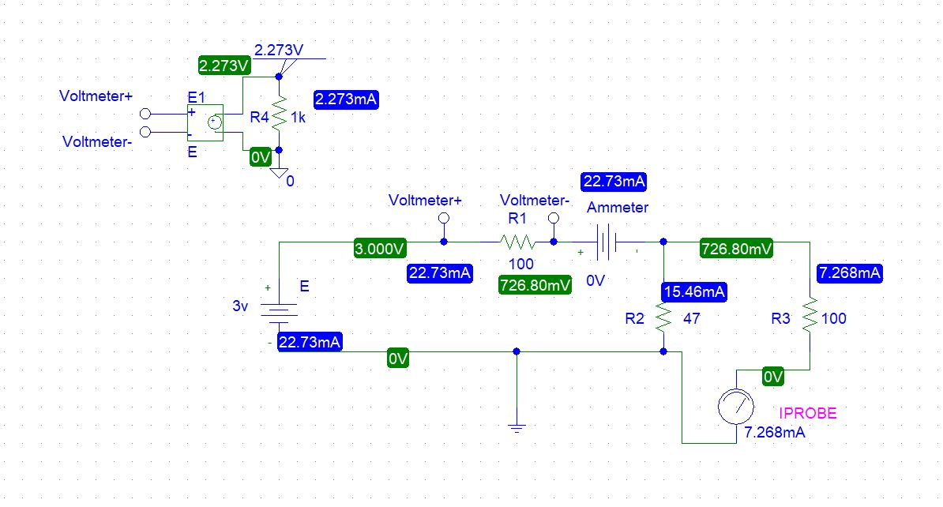**Circuit Diagram(s):**

**Figure 1. Circuit Diagram for Experiment 2**

**Experimental Datasheet:**

**Table 1 Experimental Datasheet**

|  |  |  |  |  |  |  |  |
| --- | --- | --- | --- | --- | --- | --- | --- |
| **Measured**  **Value of**  ***E (V)*** | **Measured**  **Value of**  ***V1 (V)*** | **Measured**  **Value of**  ***V2 (V)*** | **Measured**  **Value of**  ***V3 (V)*** | **Measured**  **Value of**  ***I1 (mA)*** | **Measured**  **Value of**  ***I2 (mA)*** | **Measured**  **Value of**  ***I3 (mA)*** | **Measured**  **Value of**  **Resistances**  **(Ω)** |
| 3 | 2.273 | 0.727 | 0.727 | 22.73 | 15.46 | 7.268 | *R1 =* 100  *R2 =* 47  *R3 =* 100 |

**Post-Lab Report Questions and Answers:**

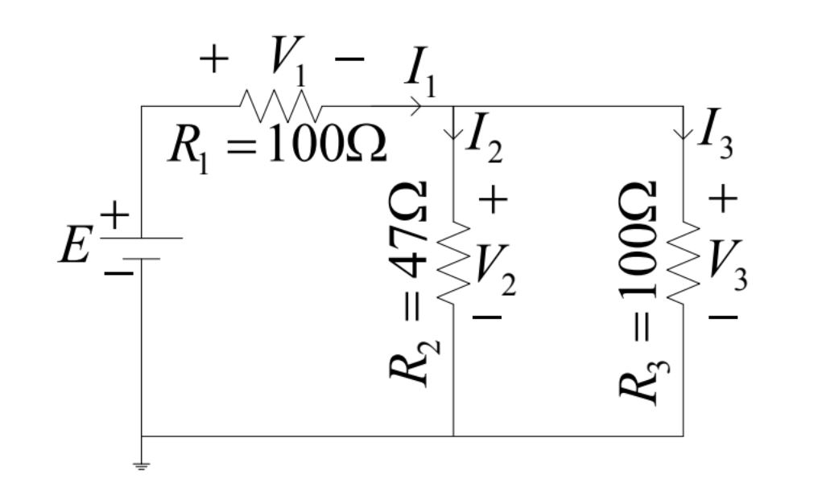

**Figure 2.Circuit Diagram**

Calculate the values of V1, V2, V3, I1, I2, and I3 of the circuit of Figure 2 using measured values of E, R1, R2, and R3. Compare the calculated values with the measured values and give reason if any discrepancy is found.

**Answer:**

Here R2 and R3 resistors connected in parallel so

Rp = R2 +R3

= 47|| 100

= 31.973 Ω

We know,

Ohm Law V=IR

Or, E = I1Req

Or, I1 =

=

= 22.73 mA

Using CDR,

I2 =

= mA

= 15.46 mA

I3 =

= mA

= 7.268 mA

V1 = I1 R1 = 100 22.73 = 2.273 V

V2 = I2 R2 = 47 15.46 = 0.727 V

V3 = I3 R3 = 100 7.268 $×{10}^{-3}$ = 0.727 V

1. From the calculated values of V1, V2, V3, I1, I2, and I3, show that
2. V1 = V2
3. *E = V1  + V2* (KVL)
4. *I1 =I2 +I3* (KCL)

**Answer:**

1. Into this circuit R2 and R3 resistors are connected in parallel. We know that parallel circuit voltage same. So, V2 =V3 are the same value.
2. Applying KVL *E* = *V1  + V2 =* (2.273 + 0.727 ) V =3 V

Or, 3 = 3

1. Applying KCL *I1 =I2 +I3* = (15.46 + 7.268) mA =22.73 mA

Or, 22.73 = 22.73

**Conclusion:**

From this experiment we have learnt about Kirchhoff’s Law of KVL and KCL and in this experiment we have learnt how to make a voltmeter to measure the voltage. Moreover, in this experiment we have used IPROBE and VDC to measure the current. Finally we have calculated the value of KVL and KCL through this experiment.